JW Sports Academy LTD

PHONE OR EMAIL TO BOOK A PLACE



**Wake up hour!**

If you are struggling to get to work on time or need to drop off your child/children early then this ‘Wake up hour’ is perfect for you!

For only an extra £2 a day, you can drop off your child at **8:30am** where they can do some arts + crafts, play board games or help our coaches set up the activities for the day where they can learn leadership and coaching skills.

We also provide each child with some juice, biscuits and a time to relax before their FUN packed day.

**ONLY £2 EXTRA PER DAY!**

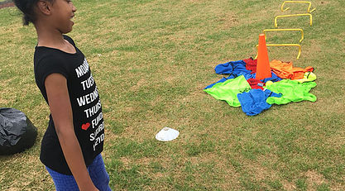

[](https://www.google.co.uk/imgres?imgurl=https://image.dhgate.com/0x0/f2/albu/g1/M00/90/15/rBVaGFayE1WAXu9hAAHvvR5Iufw205.jpg&imgrefurl=https://www.dhgate.com/product/family-funny-entertainment-board-game-uno/253430314.html&docid=Qd9fpf84XN-8nM&tbnid=Bkoc4NH-1MkenM:&vet=10ahUKEwijs4flys7cAhVpIsAKHSRoA6YQMwhkKCgwKA..i&w=650&h=524&bih=685&biw=1438&q=uno&ved=0ahUKEwijs4flys7cAhVpIsAKHSRoA6YQMwhkKCgwKA&iact=mrc&uact=8)[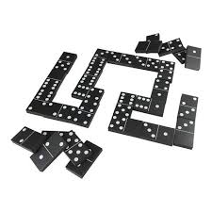](https://www.google.co.uk/imgres?imgurl=https://cdn.shopify.com/s/files/1/0999/9890/products/CLIP-033-WEB_large.jpg?v%3D1515078981&imgrefurl=https://www.traditionalgardengames.com/products/jumbo-black-and-white-dominos&docid=ZV-hlBJ0-IkvNM&tbnid=kT49DjYcook5pM:&vet=10ahUKEwid7Zm1ys7cAhUJbcAKHc6BDHkQMwiBAiggMCA..i&w=480&h=480&bih=685&biw=1438&q=dominoes&ved=0ahUKEwid7Zm1ys7cAhUJbcAKHc6BDHkQMwiBAiggMCA&iact=mrc&uact=8)

**Dates- Monday 15th, Tuesday 16th and Wednesday 17th October 2018**

[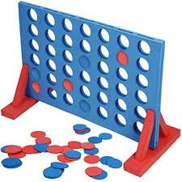](https://www.google.co.uk/imgres?imgurl=https://tesco.scene7.com/is/image/tesco/377-4858_PI_1000905MN&imgrefurl=https://www.tesco.com/direct/large-4-in-a-row-connect-4-style-garden-game-by-kingfisher/377-4858.prd&docid=6x-boE2QQbF9nM&tbnid=O61bbwOK8OqSoM:&vet=10ahUKEwjH8fGmy87cAhVReMAKHbtxBa0QMwj-AihUMFQ..i&w=400&h=400&bih=685&biw=1438&q=connect%204&ved=0ahUKEwjH8fGmy87cAhVReMAKHbtxBa0QMwj-AihUMFQ&iact=mrc&uact=8)

**Contact Details:**

Joel Wolfe – 07922694588  
jwsportsacademy@outlook.com jwsportsacademy.co.uk

**Venue**

Booth Wood Primary School

Old Ashby Road

Loughborough

Leicestershire

LE11 4PG