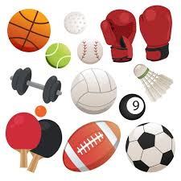
JW Sports Academy Sports Quiz (1)

- Who won the Premier league?

- In snooker, how many points is the yellow ball worth?

- How many times have England won the FIFA World Cup?

- Who does Mo Salah play for?

- True or false, in Rugby you can only pass the ball backwards using your hands?

- Name me 3 types of Gymnastics/ Swimming jumps?

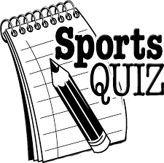
- Can you name as many Sports with a goal in it?

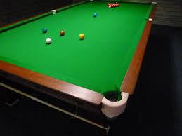

JW Sports Academy Sports Quiz (2)

- Guess the Sportsman/Sportswoman

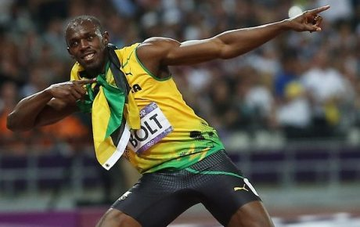

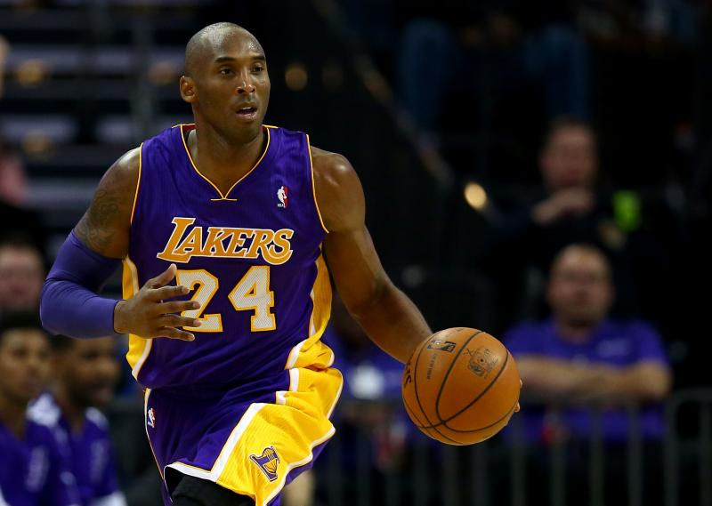
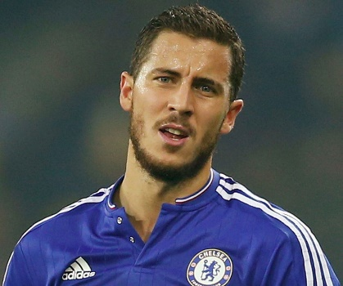
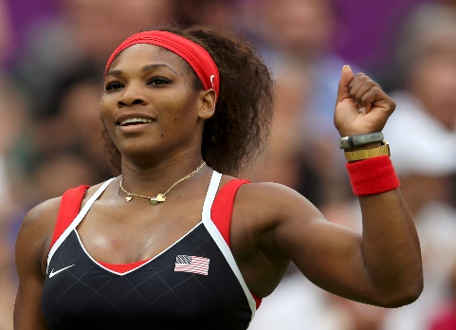

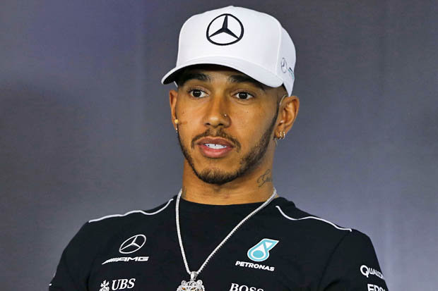
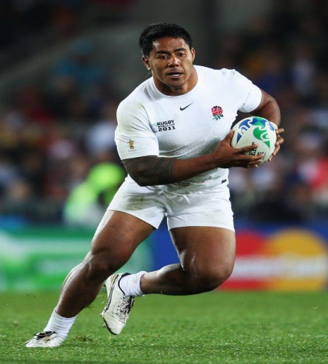
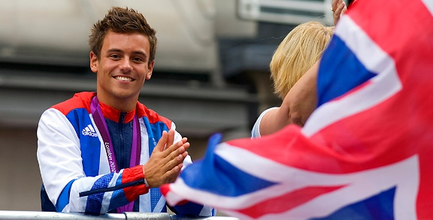
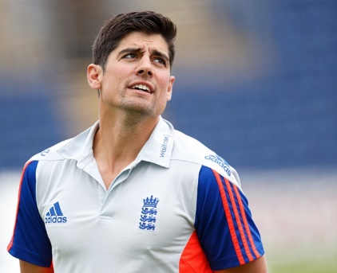
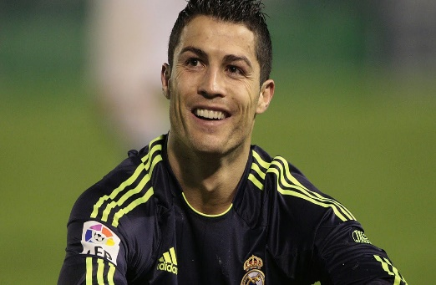

JW Sports Academy Sports Quiz (3)

- What year did the first FIFA World Cup start?

- How many times has Messi won the Ballon Dor?

- In Swimming, are you allowed to wear goggles in a race?

- How many darts do you get to throw when it is your turn?

- What are the usual coloured balls in a game of pool?

- Name me 5 different Winter Olympic Sports-

- Name me 3 different types of Dance –

- Who does Wayne Rooney play for?

- True or false, you are allowed to use your feet in Rugby?

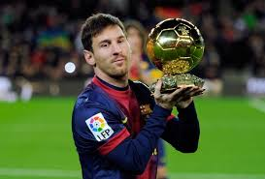

JW Sports Academy Sports Quiz (4)

First aid and the human body

- What would you put over a cut on your skin?

- True of false, a fracture is the same as a dislocation?

- Name 5 bones in the body?

- Name 5 muscles in the body?

- How many bones are in the human body?
206 150 306

- How many pints of blood are in the human body?
10 pints 5 pints 8 pints

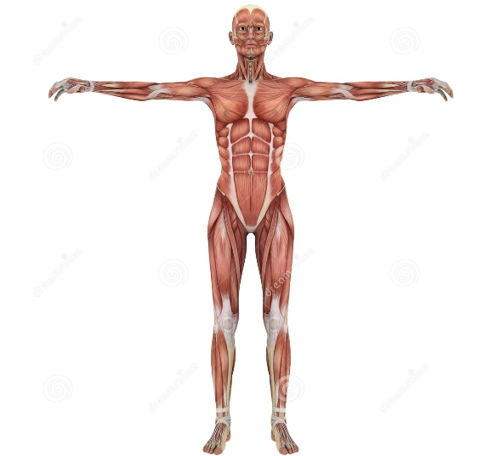
- What might you take if you have a headache?

- What number should you call if there is an emergency?

- How many hours per week should you do exercise?

JW Sports Academy Sports Quiz (5)

- Spot the differences (5 in total)
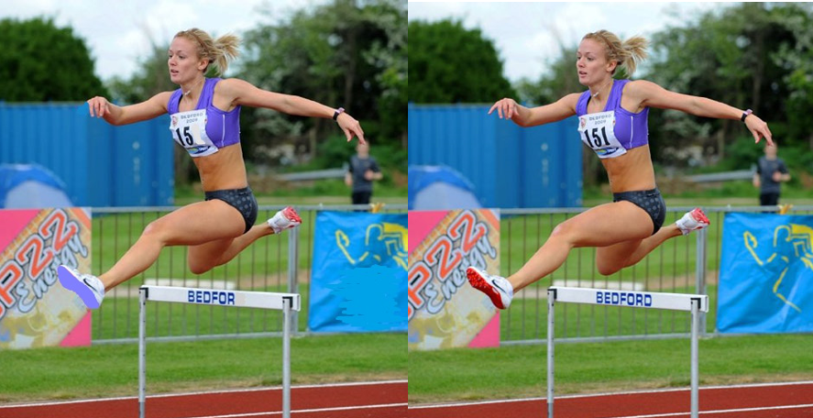

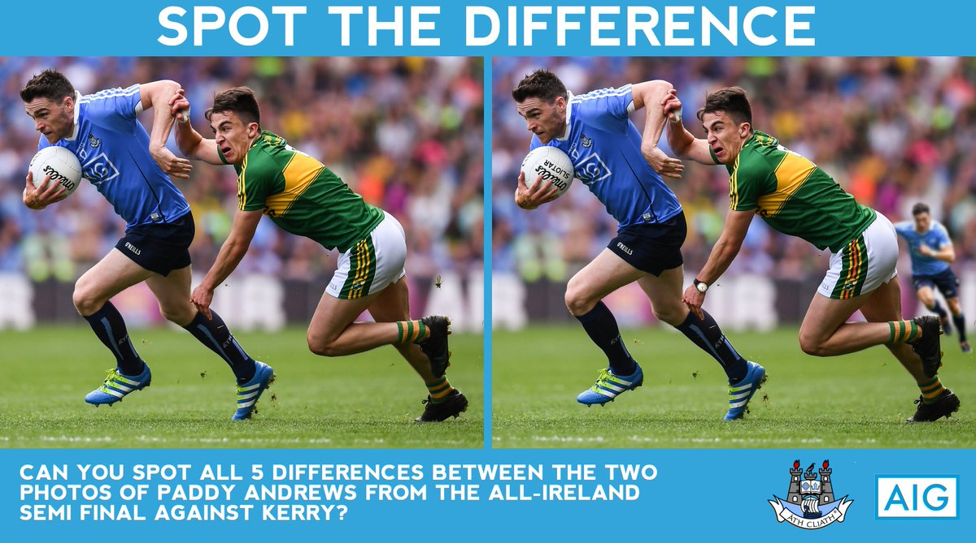
- Spot the differences (5 in total)

- Can you name as many Sports in the world as possible ( 1 point for every Sport)

JW Sports Academy Sports Quiz (2)

- Spot the differences (5 in total)
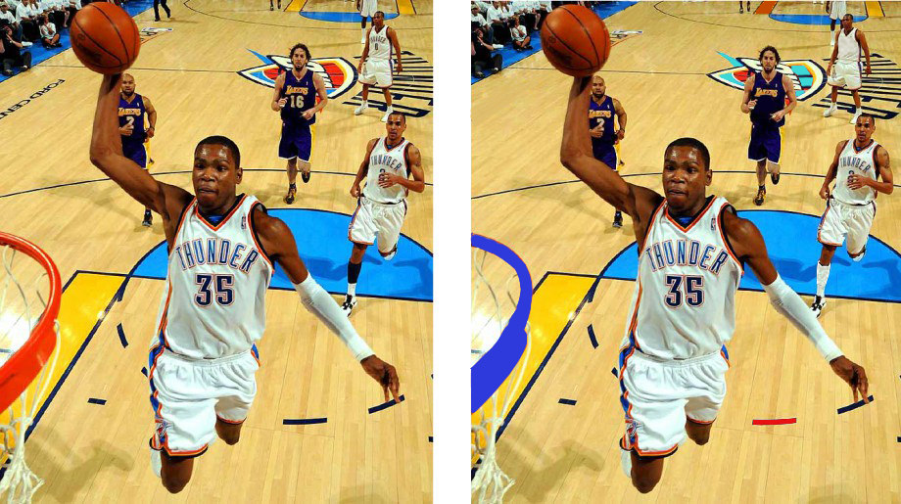
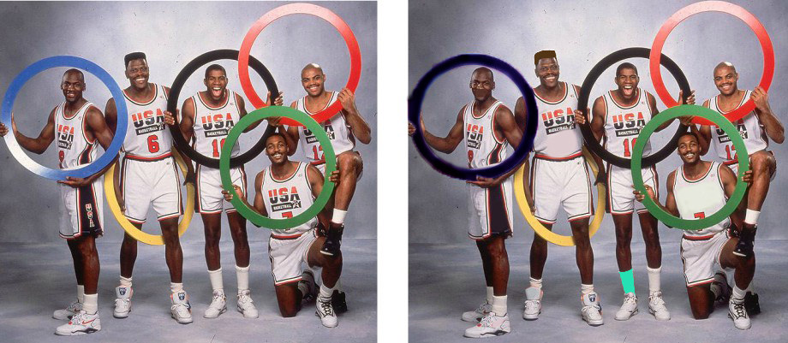

Bonus question – Can you name me as many England players that are going to the World Cup this year?
JW Sports Academy Sports Quiz (3)

- Guess the Sportsman/Sportswoman
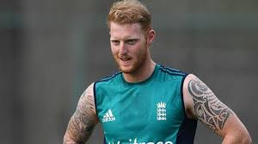
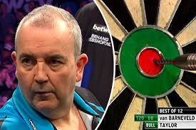
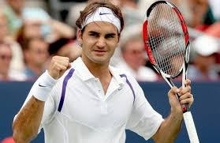
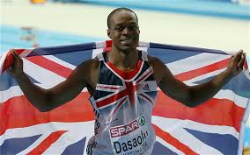
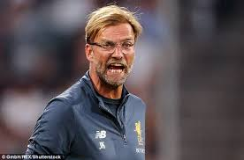
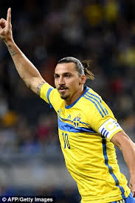

JW Sports Academy Sports Quiz (1)

Can you unscramble these sports terms?
- Ickk
- Pshu
- Ruingnn
- Spaings
- Pujm
Can you unscramble these sports players?
- Om Lasha
- Tergi Wdoos
- Awnye Oorney
- Mihclae Donjor
- Hilp Tloyar

Sports problems –
- If I score 2 goals in every home game in a season and there are 22 home games all together, how many goals would I score?

- If 1st place finished on 95 points in the Premier League, 2nd place finished with 87 points, 3rd place finished with 85 points and 4th place finished 13 points behind 2nd place then how many points did they finish up on?

- In the 100m Sprint, there were 11 runners. If 3rd place overtook 2nd place and beat him to the finish line then where would he finish in the race?

- What is the mode and median in this set of darts scores? 72 , 85 , 82 , 90 , 85 , 70 , 99 , 83 , 77 , 85 , 98 , 80

Bonus – can you name 10 English Footballers who play in the Premier League?

JW Sports Academy Sports Quiz (2)

Can you name these teams?
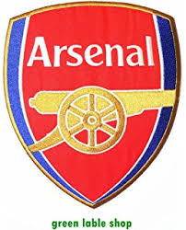

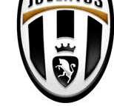

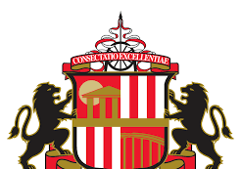
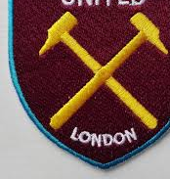

JW Sports Academy Sports Quiz (3)

First aid – True or false

- A baby has more bones than an adult does?
- The colour of blood in your fingernails is green?
- Men have more teeth than women?
- Every time you shower, you lose 330 small pieces of hair?
- The heart is near the left side of the chest?
- Your brain can survive 5-10 minutes without oxygen?
- In severe starvation when you haven’t ate for many days your brain will start eating itself?
- Your ears and nose never stop growing?
- Every time you blink, you lose 1 eyelash?
- Your foot is this same length as your forearm?

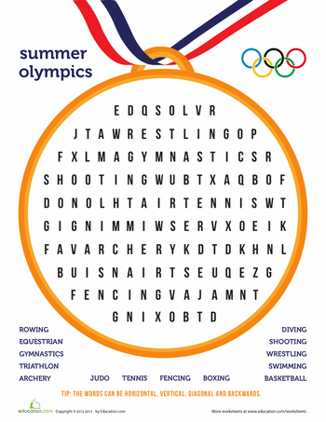

Each word you find is 1 point!

JW Sports Academy Sports Quiz (4)

- Who has Riyad Mahrez signed for this summer?

- How many times have South Africa won the Rugby World Cup? 3 / 4 / 5

- Who won the Men’s Wimbledon Final this year?

- What is the maximum players you can have on a Tennis court at one time?

- What is the piece of equipment called that they hit in badminton?

- What sports do you have to go backwords to win?

- Name 5 water sports?

- Name 5 track events at the Olympics?

- Name 5 field events at the Olympics?

- What is a risk assessment?

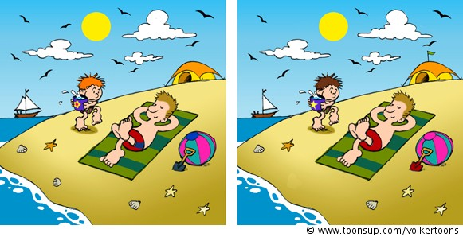
Spot the differences!
JW Sports Academy Sports Quiz (2)

Coaches’ quiz –

- Which is the oldest and youngest coach?

- Which coach has played for Nottingham Forrest FC when they were younger?

- Which coach is a Dance teacher?

- Which doesn’t like Dark chocolate?

- Who are the two siblings out of the coaches?

- Which coach is terrified of spiders?

- Which coach used to be a firefighter?

- Which coach lives in Loughborough?

- Which coach supports Arsenal?

Bonus questions –
- True or false, Mr Wolfe loved the colour pink so much when he was younger; he bought a whole outfit in pink?
- True of false, Stuart is 45 years old?
- True or false, Bethan doesn’t like chips?
- True or false, Ava was in High School Musical when she was younger as a junior dancer?
- True or false, Ben’s favourite animal is a horse?
- True or false, Mr Wolfe drives a SEAT Leon?
- True or false, Stuart’s favourite sport is Badminton?
- True or false, Bethan has once dislocated her knee?
- True of false, Ava likes to play the piano in her spare time?
- True or false, Ben is a qualified Doctor?

JW Sports Academy Sports Quiz (1)

- Who has Cristiano Ronaldo play for?

- What do the Americans call football?

- Who is the current N.B.A best shooter in terms of most points per game?

- What car does Lewis Hamilton drive in the F1?

- Can you name five different sports brands?

- What piece of equipment do you have to wear under your socks in Hockey and Football?

- Who is the current world number one in Tennis?

- Who has the most test wickets in Cricket?

- How many sports balls are on the JW Sports Academy LOGO?

- What make is the Premier League ball?

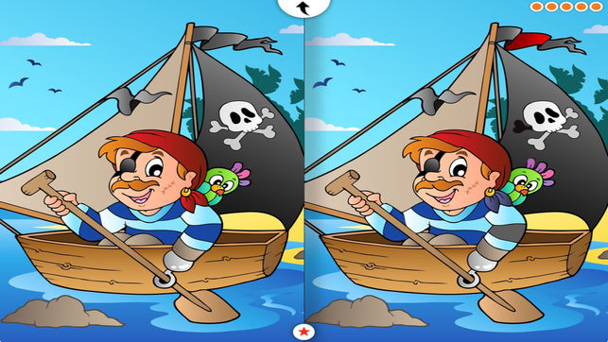
Can you spot the five differences?

JW Sports Academy Sports Quiz (3)

- What was the final score in last seasons Champions League final between Liverpool and Real Madrid?

- Can you name 10 players who play for the England football team?

- Can you name 5 different balls used in sport?

- Can you name 5 different pieces of equipment you might use to hit something in sports?

- What year did Leicester City win the Premier League?

- Who has the nickname ‘Special one’ in football?

- Can you name 10 different countries in Europe?

- How many points is the blue ball worth in Snooker?

- How can you get out in Cricket? ( 1 point per answer)

- What might boxers wear in their mouth?

Unscramble
- Ootbalfl
- Ockhye
- Derouns
- Ballsabe
- Mminswig
- Oxignb
- Nogl pumj
- Leurhds
- Cetrikc
- Doballdge

JW Sports Academy Sports Quiz (1)

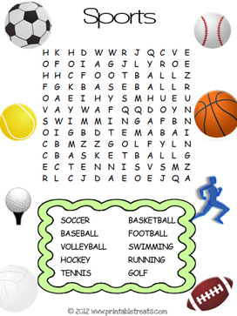

Bonus questions –
- Who are currently top of the Premier League?
- Which sport uses a puck?
- How many players are on a Rugby field at the start of the game?
- What sport does Tiger Woods play?
- Can you name three swimming strokes?
JW Sports Academy Sports Quiz (2)

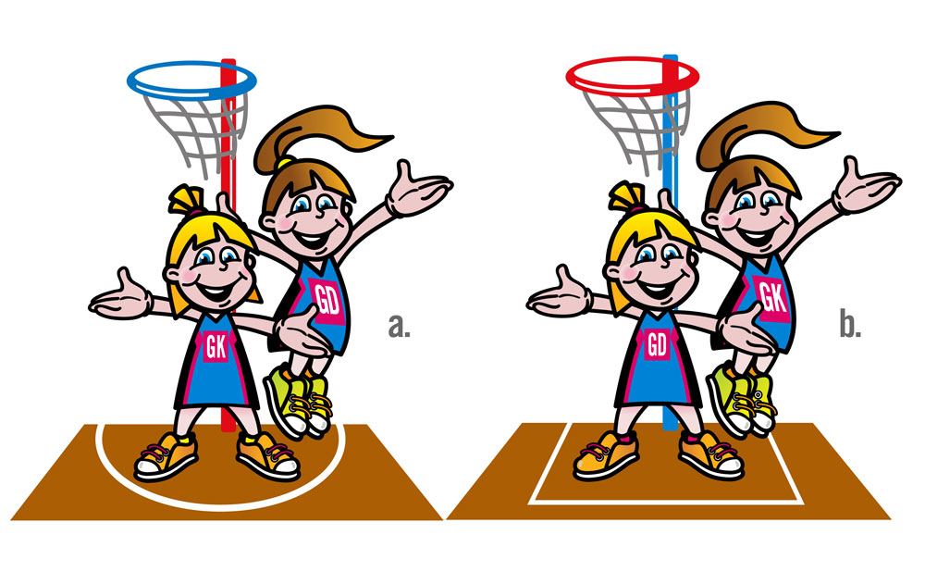

True or false –
- Arsenal have never won the Champions League?
- The nets in Tennis are 6 foot long?
- In Badminton, you use a soft ball to play with?
- The blue ball in snooker is worth 5 points?
- Marcus Rashford is English?
- Leicester City’s manager is French?
- In Swimming, you have to wear goggles in a race?
- France won the FIFA world cup last year?
- In Gymnastics there is a move called a round off?
- Volleyball is not a sport that is played in the Olympics?

JW Sports Academy Sports Quiz (3)

Guess the coach-

- Which coach is the youngest?
- Which coach has a blue car?
- Which coach plays football?
- Which coach has never been to America?
- Which coach doesn’t like mushrooms?

Name the player- (BONUS POINT IF YOU CAN SAY WHAT SPORT THEY PLAYED)
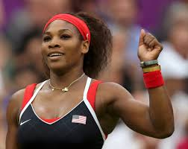
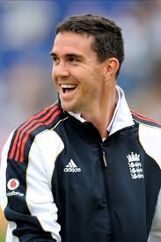
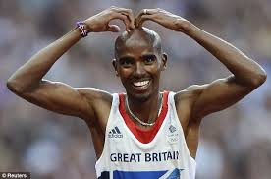
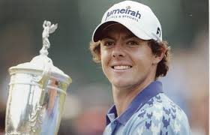

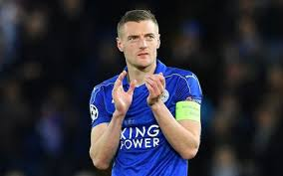

JW Sports Academy Sports Quiz (1)

- Do you know how many players there are in an ice hockey team?

- What does the term 'birdie' mean in a game of golf?

- In a game of snooker, how many red balls are there on the table at the beginning of the game?

- Which flag is waved in motor racing to show the winner?

- What is Zumba?

- How many times have Arsenal won the Premier League?

- Which country invented Volleyball?

- What is the name of the flat rubber disc used in a game of ice hockey?

- What color is the centre of the target in archery?

- In a game of darts, what is the highest possible score using three darts?

JW Sports Academy Sports Quiz (2)

- What size football do professionals play with?

- How many holes are there in a bowling ball used in a game of tenpin bowling?

- What are the colors of the five Olympic rings?

- How many pockets are there on a snooker table?

- Which chess piece holds the most value on a chess board?

- Which country invented the game baseball?

- How many players are there in a rugby union team?

- Can you unscramble the following word to reveal a type of sport: GINKIS?

- What is the name of the racquet game played in a closed wall court with a small rubber ball?

- How many bases must be completed/passed in a game of rounders to score a point?

JW Sports Academy Sports Quiz (3)

- Which of the following sports does not involve a ball: tennis, squash, or badminton?

- In which sport do you run and jump as far as possible onto a sandpit?

- What colour is a standard tennis ball?

- Which sport involves a bat, a ball and wickets?
- In which game do you aim to knock down ten pins with a ball?

- What are ballet, tap and hip-hop all types of?

- Which sport uses the lightest ball: a) Football, b) Baseball, c) Table tennis?

8. Which outdoor sport involves a club, a ball and holes in the ground?
9. What type of sport is played on horseback?
10. What colour is Liverpool Football Club’s home kit?
JW Sports Academy Sports Quiz (1)

- Which wizarding sport played on broomsticks does Harry Potter play?
- Name the golfer who first name is the same as a big cat?

- Which country does footballer Lionel Messi play for?
- How many rings are there on the Olympic flag?

- Which sport did Johnny Wilkinson and Martin Johnson play?
- Which swimming stroke has the same name as a flying insect?

- Is Mo Farah a champion at athletics, football, swimming or tennis?

- What do players call the hard rubber disc they hit in hockey?

- A caddy is the person who carries a player's bag in which sport?

- Which important horse race is jumped over fences at Aintree and was once won by Red Rum?

- How many goals are scored if a player has a hat-trick?

- How many players are there in a basketball side?
JW Sports Academy Sports Quiz (2)

- In which football stadium do Manchester United play all their home matches?

- In the Olympics you get a gold medal for coming first, what do you get for coming second and third (two answers)?

- In which country did the Olympic games originate?
- Andy Murray is a chamion at which sport?

- What food does former footballer Gary Lineker advertise on television?

- What do teams pull in a game of tug of war?
- What colour balls are worth one point in a game of snooker?

- How many vertical wooden stumps make up a cricket wicket?

- What do players hit in a game badminton?

- What name is given the spear like object thrown in athletics at the Olympics?

- Michael Phelps has won the most Olympic medals ever; which sport did he compete in?
- Which football team are also called The Gunners?

JW Sports Academy Sports Quiz (3)

- Which colour jersey does the leader in the Tour de France cycle race wear?
- Which Welsh footballer plays as a winger for Spanish club Real Madrid?

- Which American boxer was known as 'The Greatest'?
- How many points does a player get for a try in rugby?

- In which sport might you hear the score announced as '30–love'?
- In which athletics event is a long stick used to jump over a high bar?

- A pommel horse is a piece of apparatus in which sport?
- Which sport takes place in a velodrome?

- In which sport can you get a hooker, lock, scrum-half and outside-half?
- Which country has won the football world cup most times?

- In which sport can you get 'a hole on one'?
- Which sport is also known as ping pong?

